3.6 Directional Derivatives and Gradients

Recall: Suppose we have a surface given by the two variable function .

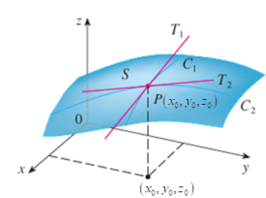
If the coordinates of are , then the partial derivative is the slope of the line tangent to the curve at P, or we can say that it is the rate of change of z at P in the direction of the unit vector .

Moreover, the partial derivative is the slope of the line tangent to the curve at P, or we can say that it is the rate of change of z at P in the direction of the unit vector .

Motivation: Suppose we wanted to move across in a direction that was not parallel to i or j. How could we determine the rate of change of z at P in the direction of an arbitrary unit vector ?

Definition: The directional derivative of at in the direction of a unit vector is .

Note: If we get the definition of the first x partial, and if we get the definition of the first y partial!

Note: It is extremely important to remember that directional derivatives are always computed in the direction of a UNIT VECTOR!!!!!!

The next theorem gives us an easy way to compute directional derivatives. As long as our starting function is differentiable.

Theorem: Suppose that is a differentiable function of x and y, then has a directional derivative in the direction of any unit vector and .

Proof: Suppose that g is a function of a single variable given by (we view , a, and b as constants). Then, by the definition of derivative we have that .

Now, let and . Then, , and we know by the chain rule: . So, .
Therefore, .

Example 1: Consider the function .

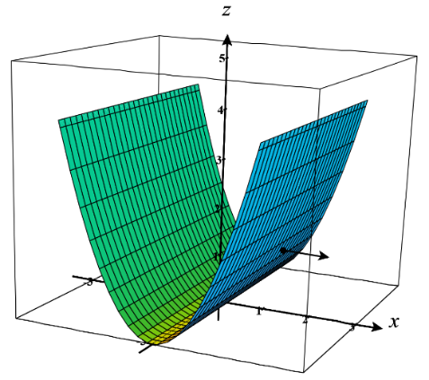
- Find the directional derivative of the function at the point in the direction of the vector .

We note that v is already a unit vector and so we compute:

This means that the slope of the tangent line at this point, in the direction of v is 2.

- How does your answer in part (a) relate to the slope of the tangent line on the graph of at the point when ?

This result is perfectly consistent with the slope of the tangent line that we would expect to find on at the point when ! This shows us that the idea of derivatives that we had for functions in Calculus I is being extended to surfaces produced by function and the general idea of a directional derivative.

Example 2: Find the directional derivative of the function at the point (1,2) in the direction of the vector . (Hint: Directional derivatives must be computed in the direction of a unit vector!)

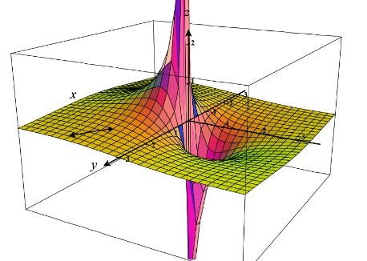
We know we must compute the directional derivative in the direction of a unit vector. A unit vector which points in the same direction as v is .
We note that and .
We note that since the first partials are continuous at (1,2), the function is differentiable at (1,2) and the most recent theorem applies.
Thus,

Question to the Class:
Recall that if is a differentiable function of two variables and is a unit vector, then . Can we rewrite this formula as a dot product as vectors?

Answer: The answer is yes. With a little manipulation we see that
. So, in this case we are able to compute the directional derivative with a dot product. As it turns out the other vector (besides u) that appears in the dot product is quite important, and it is the focus of the next definition.

Definition: If is a function of two variables x and y, then the gradient of is the vector function defined by .

Note: With this definition we have that .

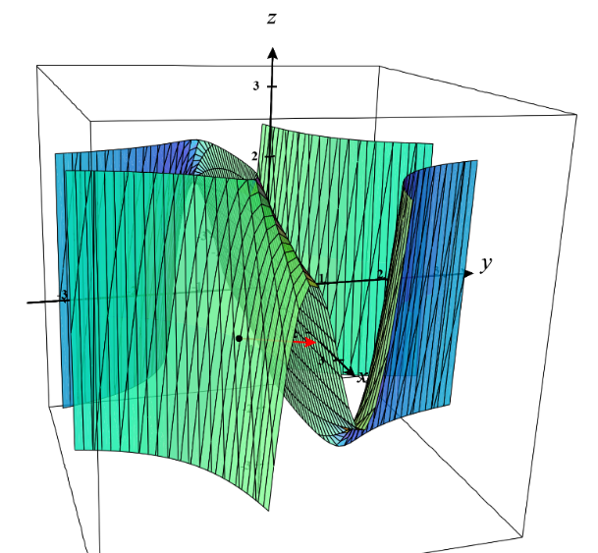
Example 3: Find the directional derivative of the function at the point in the direction of the vector .

We note that a unit vector in the direction of v is .
We also note that the gradient of is .
So, .

The notion of directional derivative extends in a natural way to functions of more than two variables. The next few definitions address this.

Definition: Suppose that is a function such that and u is a unit vector in . Then, the directional derivative of at in the direction of u is .

Definition: If is a function of three variables, then the gradient vector of is .

Theorem: Just as with functions of two variables, if is a differentiable function of three variables and u is a unit vector, then .

Proof: One only needs to extend the proof for two variable functions.

Note: The notion of gradient and the above theorem extends beyond three variable functions.
Example 4: Suppose that .
- Find the gradient of f.

We note that .

- Find the directional derivative of f at (1,3,0) in the direction of .

We note that is a unit vector which points in the same direction as .
So, .

- How should the unit vector be chosen so that is maximized?

The answer is that we should choose u to be . A discussion of how one obtains this follows.

Exploration:
Suppose that f is a two or three variable function which is differentiable. Suppose that we want to find a unit vector u so that is as large as possible.

We know that where is the angle formed between .
Now, the largest that can be is 1, and it is 1 when , that is when are parallel and point in the same direction. So, we should take (Assuming of course that the gradient of f at x is not the zero vector. If it is, the directional derivative will be 0 regardless of u). The result of this exploration is summed up by the following theorem.

Question: What should we take u to be to make the directional derivative as small as possible?

Theorem: Suppose that is a differentiable function of two or three variables.
The maximum value of the directional derivative is and it occurs when u has the same direction as the gradient vector .
Moreover, the minimum value of the directional derivative is and it occurs when u points in the opposite direction of the gradient vector .

Note: We will often sum up the above theorem by saying that the gradient of a function points in the direction of the function’s steepest increase.
Example 5: Suppose you are skiing on a mountain whose surface is given by the equation . You are currently at the point on the surface.

- In the direction of which unit vector should you ski if you want to ski in the direction of the steepest decrease?

If , then . At the point (1,2,1) on the surface, we know that the vector points in the direction of the steepest increase.
So, the vector points in the direction of the steepest decrease.
Thus, the answer is .

- What is the rate of decrease when you travel in the direction of the unit vector you found in (a)?
Based on the most recent theorem, the answer is .

Note: If you graph the given surface and vector you can see that it points you towards moving “down” the surface as quickly as possible.

Note: We can think of the gradient as a “compass needle” that points us in the direction of greatest increase at any given point on our surface. It is important to note that this “compass needle” only consists of an x and y direction and doesn’t depend on z in any way.

